|  |  |
| --- | --- |
| Name | Mughees Khalid |
| Ag # | 2018-ag-1759 |
| Section | A |
| Github ID | <https://github.com/11Mughees/cs-625.git> |

**Assignment week 1**

**Question#1**





**Question#2**



**Question#3**



**Question#4**

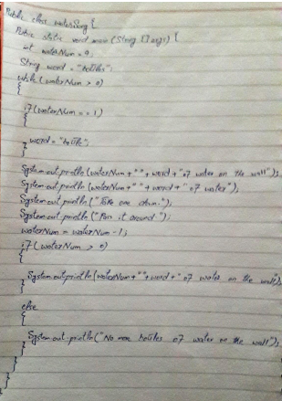

**Question#5**

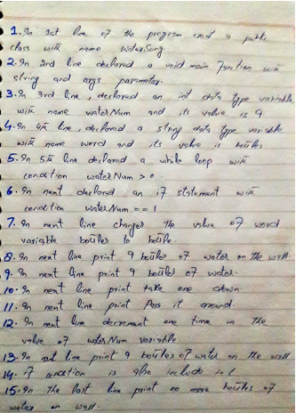

**Question#6**



**Question#7**

